**DAILY ONLINE ACTIVITIES SUMMARY**

|  |  |  |  |  |  |  |  |  |
| --- | --- | --- | --- | --- | --- | --- | --- | --- |
| **Date:** | **19-05-2020** | | | | | **Name:** | **Latika Kavoor** | |
| **Sem & Sec** | **4th Sem & A-Section** | | | | | **USN:** | **4AL18CS035** | |
| **Online Test Summary** | | | | | | | | |
| **Subject** | | **DAA** | | | | | | |
| **Max. Marks** | | **30** | | **Score** | | | **7** | |
| **Certification Course Summary** | | | | | | | | |
| **Course** | **Introduction to Cyber Security** | | | | | | | |
| **Certificate Provider** | | | **ICT Academy - CISCO** | | **Duration** | | | **30 hrs** |
| **Coding Challenges** | | | | | | | | |
| 1. **Problem Statement:**1. We have a Letter or a word then we need add some letters to it and need to find out shortest palindrome For example we take "S": S will be the shortest palindrome string. If we take "xyz": zyxyz will be the shortest palindrome string So we need to add some characters to the given string or character and find out what will be the shortest palindrome string by using simple java program. 2. Write a simple code to identify given linked list is palindrome or not by using stack. First take a Stack. Traverse through each node of the linked list and push each node value to Stack. Once the traversal & copying is done, iterate through linked list from head node again. In each iteration, pop one stack element and compare with node value in respective iteration. It is expected to match stack popped value with node value. In case of all matches, its a palindrome. Any one element mismatch makes it not a palindrome. | | | | | | | | |
| **Status: Completed** | | | | | | | | |
| **Uploaded the report in Github** | | | | | **Yes** | | | |
| **If yes Repository name** | | | | | <https://github.com/Latika31/lockdown-coding> | | | |
| **Uploaded the report in slack** | | | | | **Yes** | | | |

Online Test Details: (Attach the snapshot and briefly write the report for the same)

DAA test was conducted on 19-05-2020 online from 9:15 to 9:55

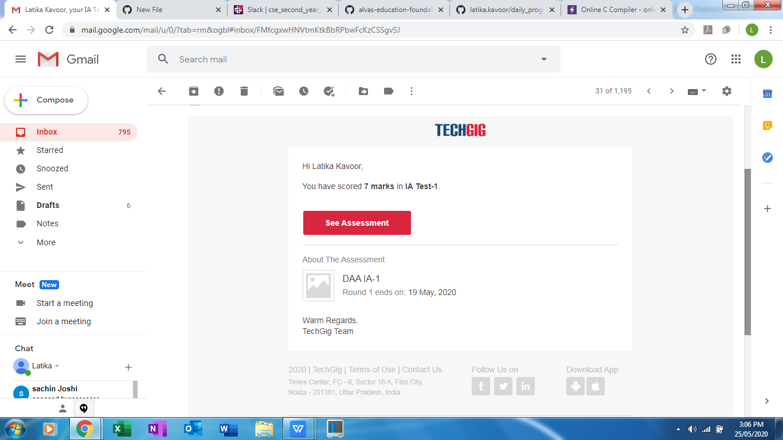

Certification Course Details: (Attach the snapshot and briefly write the report for the same)

I continued the introduction part and learnt about protecting the data concepts 

Coding Challenges Details: (Attach the snapshot and briefly write the report for the same) ------- Solved 2 problems and uploaded on github 